KR Industries Completed Workload Migration Plan
Workload | Current  State | Business  Importance | Complexity | Priority
Virtual Machine (KR-vmB1s) | Migrated to Azure and accessible via public IP | High | Medium | 1
SQL Database (krindustriesdb) | Migrated to Azure MySQL | High | High | 2
Web Application (KRIndustriesWebapp) | Deployed to Azure Web App and connected to Azure MySQL | High | High | 3
File Storage | Migrated to Azure Blob/File Storage | Medium | Low | 4
Data Backup ( Backup) | Configured Recovery Services Vault and backup policies | Medium | Medium | 5

Detailed Migration Steps
----Virtual Machine Migration to Azure----
Tools: Azure portal

- In the Azure portal, create a virtual machine and assign a public IP address for remote access.
- Install necessary applications and services to ensure the virtual machine is operational.
- Access the virtual machine using SSH or RDP to confirm system stability and connectivity.
- Outcome:
Public IP address: http://20.205.21.46/ and http://20.205.21.46/index.php
(You can access the virtual machine using the public IP above)

VM is accessible via SSH 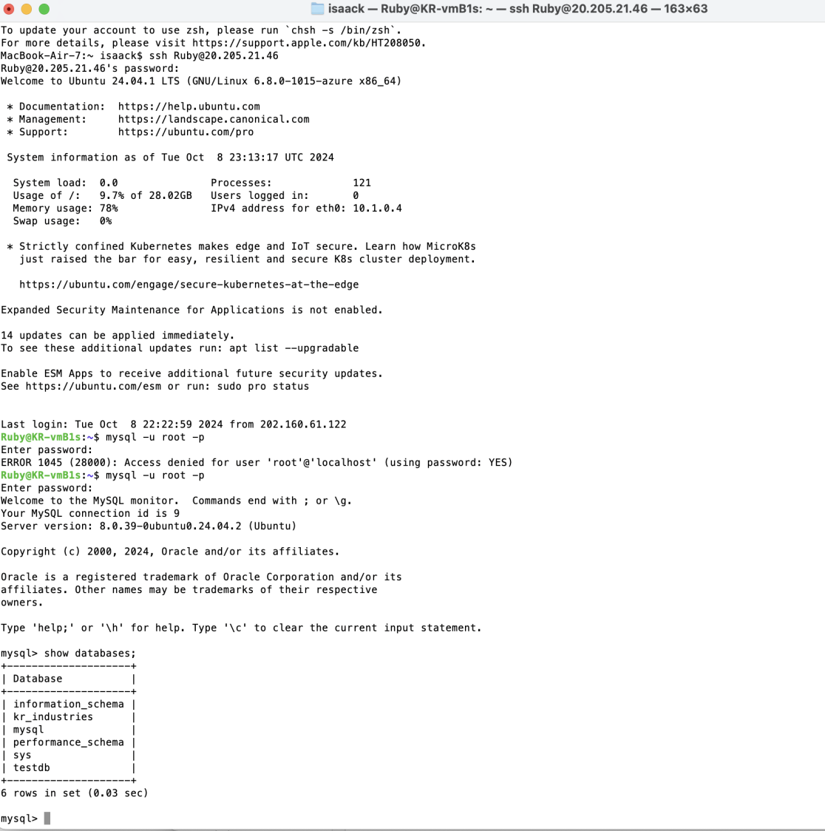

----SQL Database Migration to Azure MySQL----
Tools: Azure Database Migration Service (DMS)，MySQL Workbench

1. Set up an SSH tunnel to connect your local MySQL Workbench to the MySQL instance on the virtual machine (VM), allowing a secure connection.
2. Modify the MySQL configuration file on the VM and set the bind-address to 0.0.0.0 so it can accept connections from external sources .Grant remote access permissions to the root user
3. Add an inbound rule in the NSG to allow traffic on port 3306 for MySQL. In the Azure MySQL settings, enable public access and add the IP addresses of the VM and other clients that need to connect.
4. Migrate the Database Using DMS
5. After the migration is complete, use MySQL Workbench to connect to the Azure MySQL instance and check if the data has been successfully transferred.
6. Outcome:
VMS SSH connection
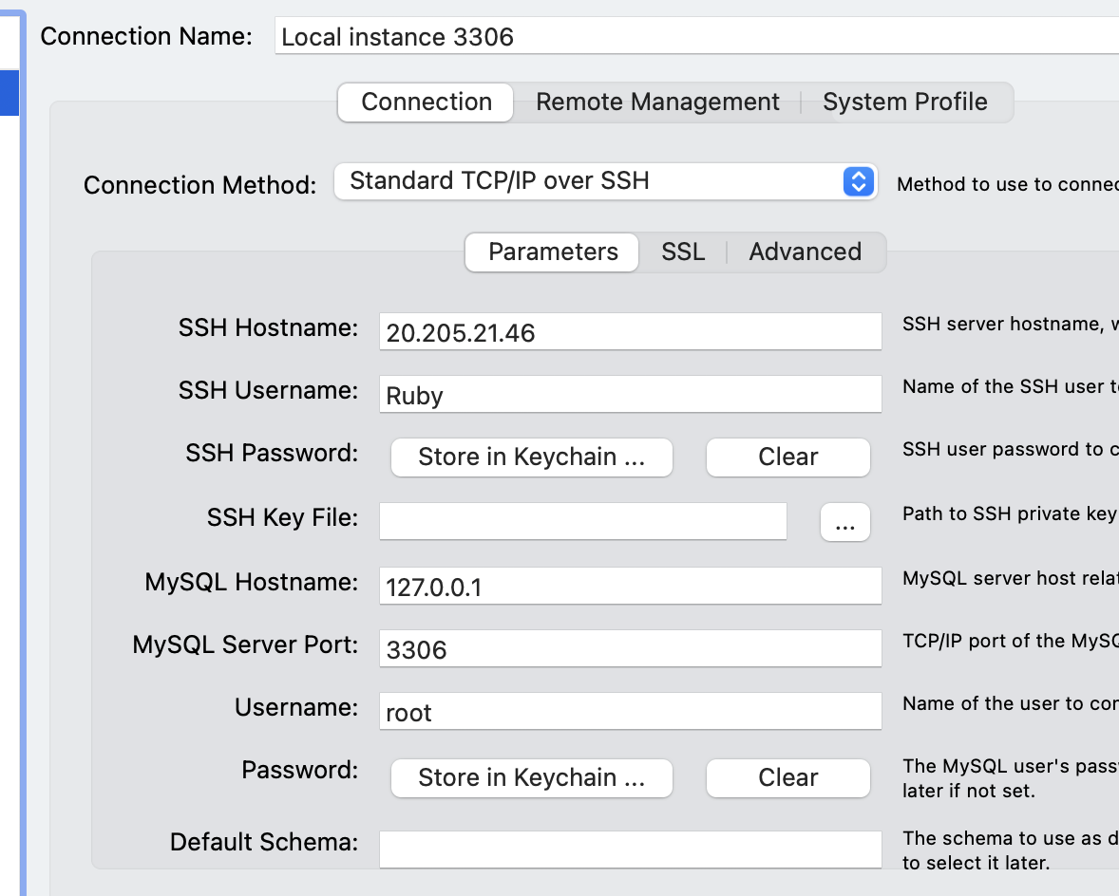
(DMS) Database Migration completed
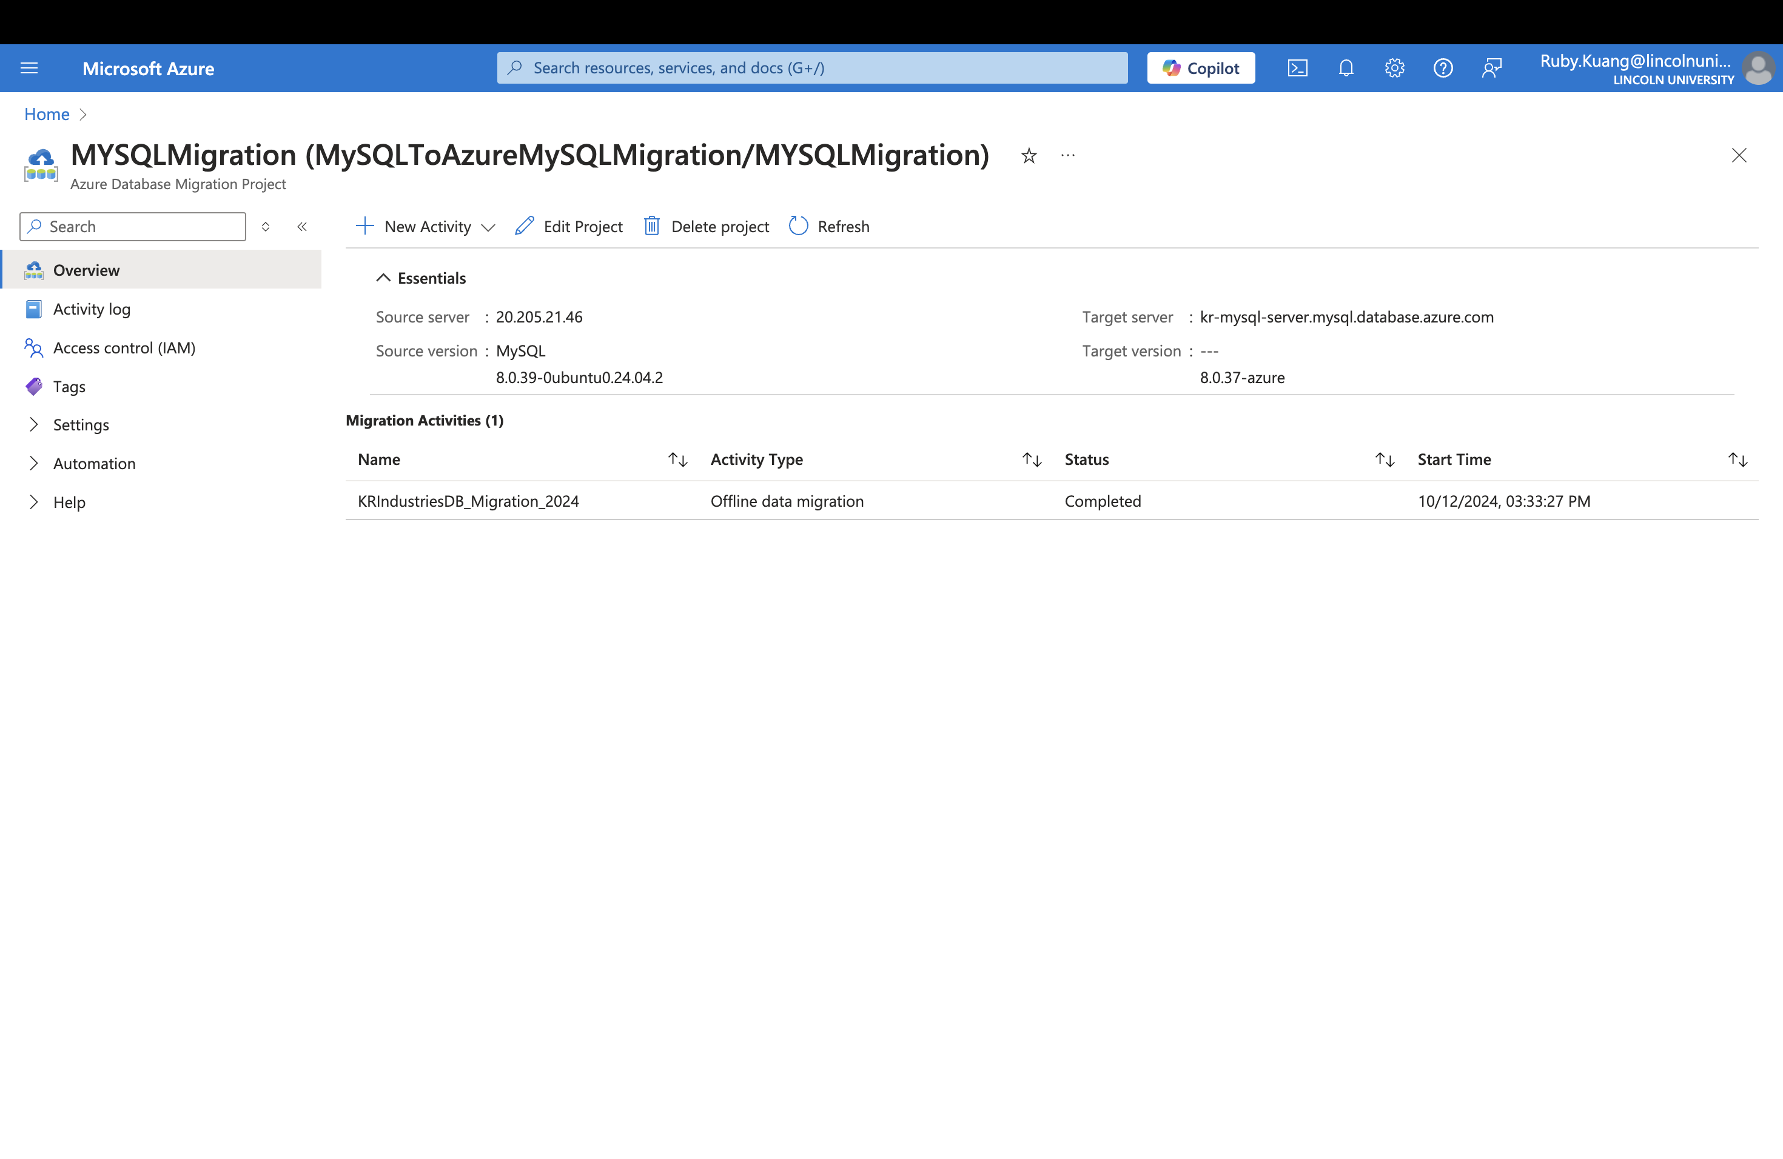

Database stored
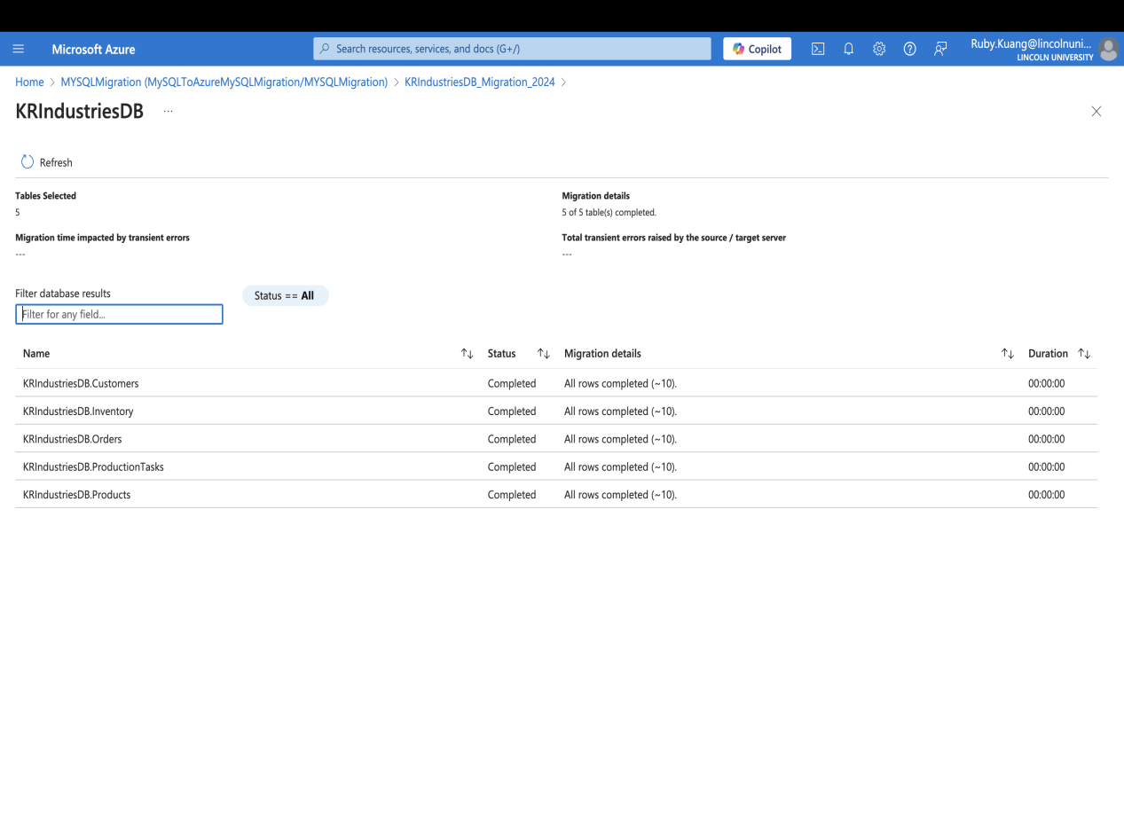

MySQL connection
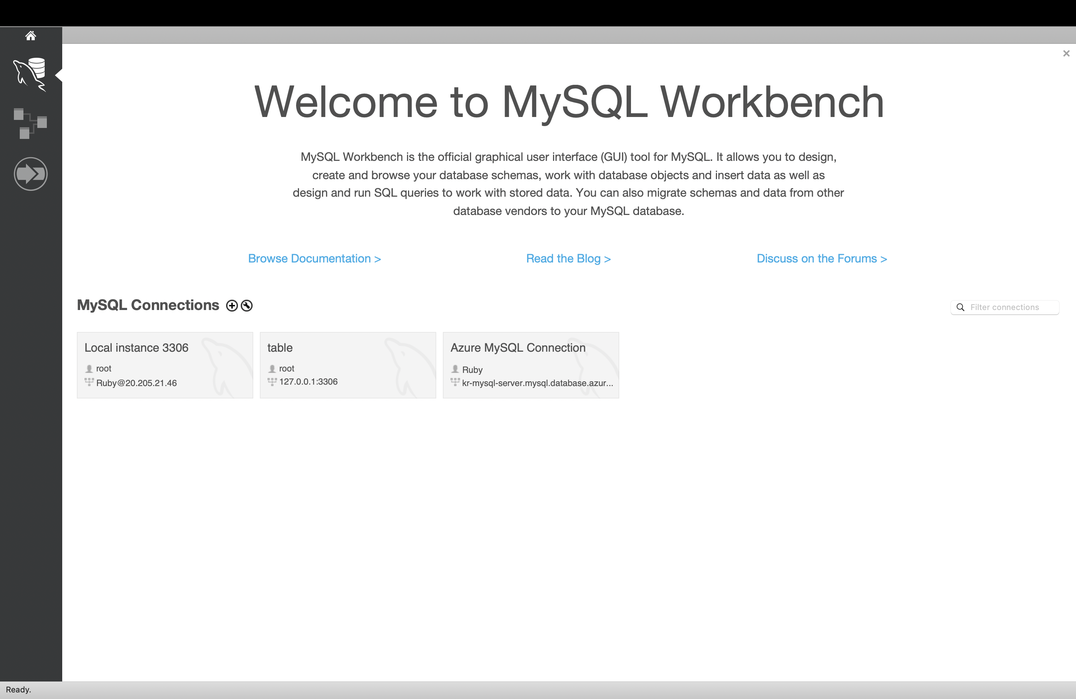

Data testing
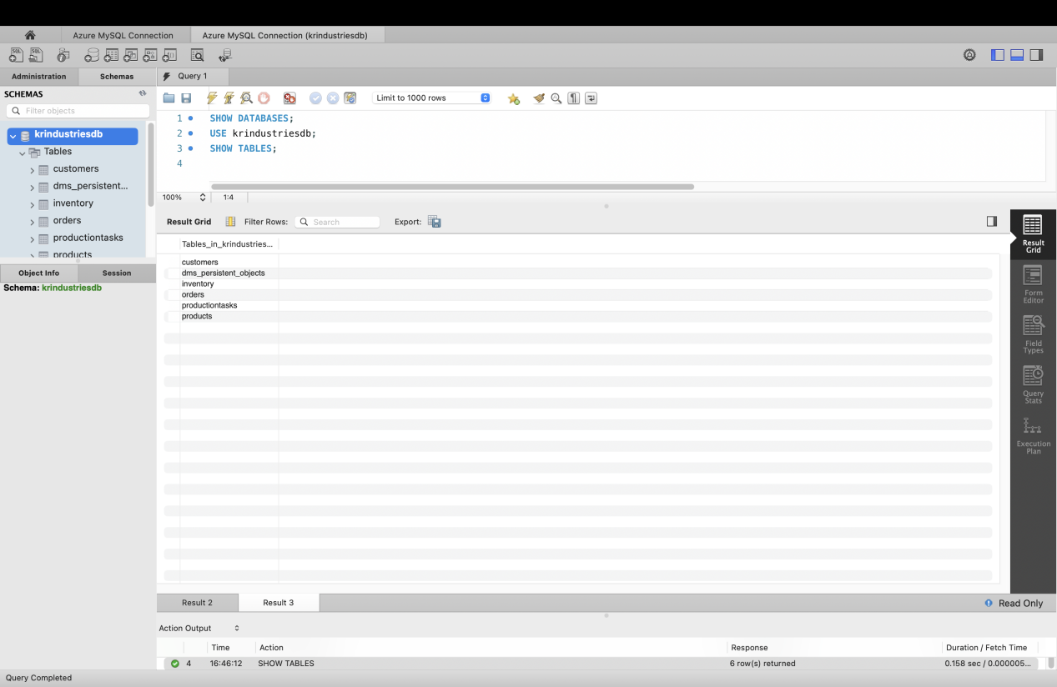

----Web Application Migration to Azure Web App----
Tools: GitHub Actions, Azure App Service
Steps:
- Develop a simple Flask Web Application showcasing data such as products, customers, and orders, connected to the Azure MySQL database.
- Push the web application code to a GitHub repository and configure GitHub Actions for automated deployment.
- In the Azure portal, create an App Service plan and App service. Set up GitHub integration to enable automatic deployment to Azure.
- Verify that the web application runs successfully in Azure and can access the Azure MySQL database.
- Outcome:
web application URL:
https://krindustrieswebapp-h3aggbg4d8gmhbeb.eastasia-01.azurewebsites.net/
GitHub Project:
https://github.com/RubyKuang/Azure-HybridCloudMigration

Github Action deploy succeed
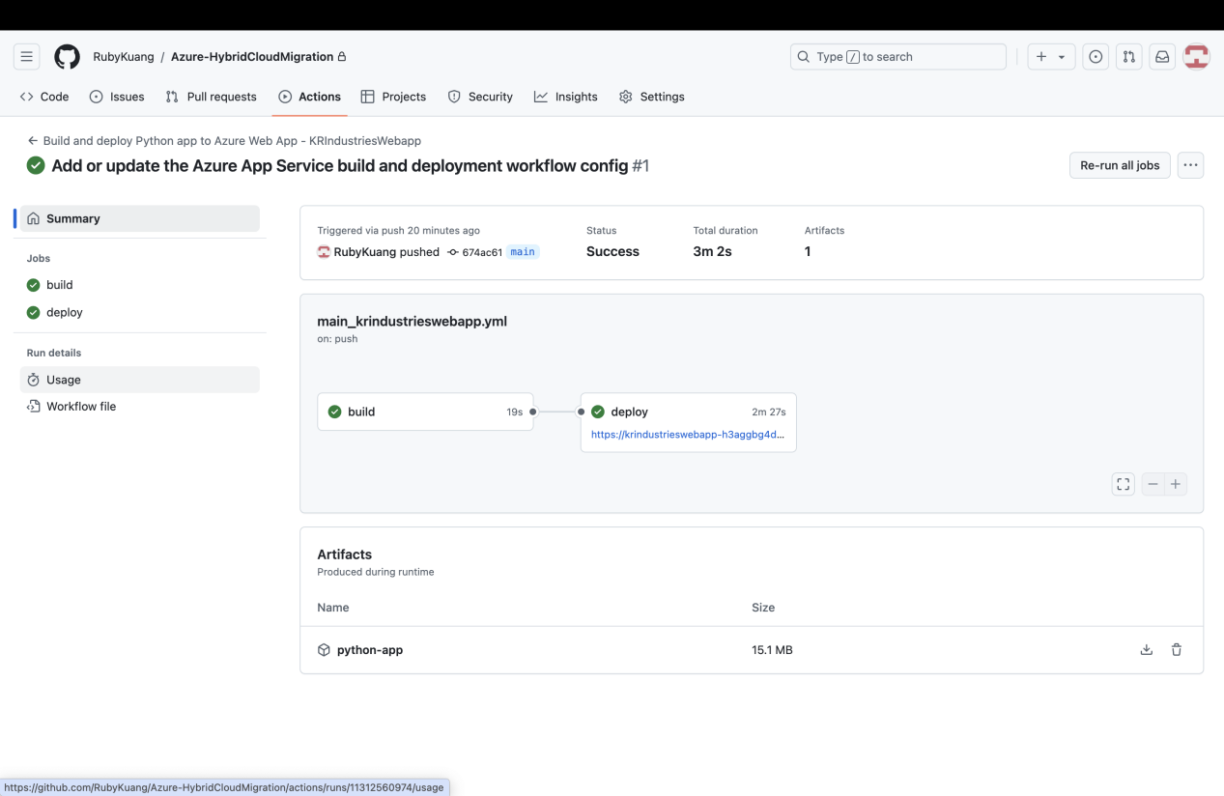

Azure App Service
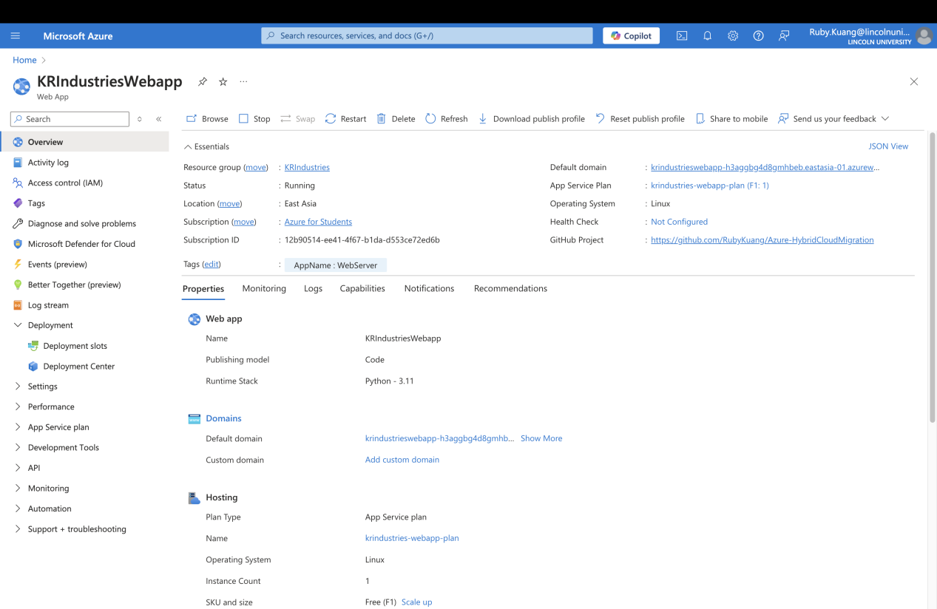

Azure webapp Deployment Center
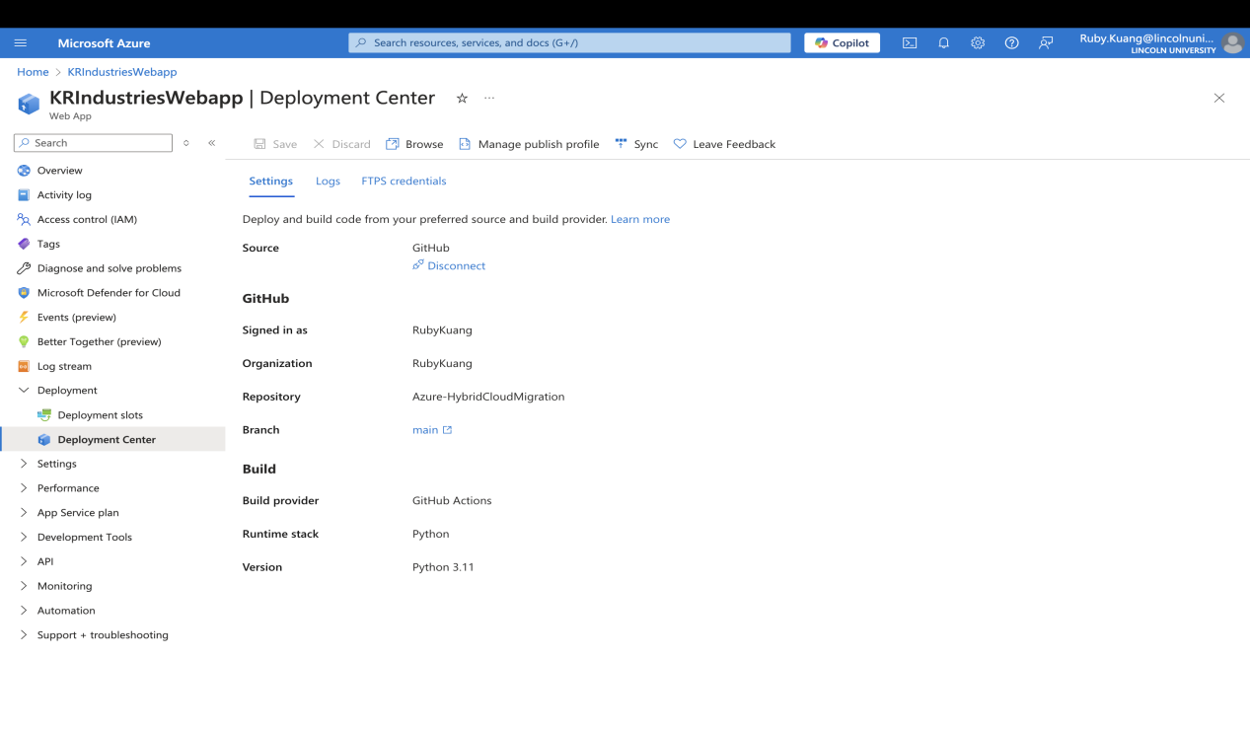
----File Storage Migration to Azure Blob/File Storage----
Tools: Azure portal, Storage account
Steps:
- Create an Azure storage account and select Blob Storage.
- Create a new Container for the storage account.
- Upload the local folder KR-Files to Azure Blob storage.
- Verify the successful upload of files and check file integrity and storage status.
- Outcome:
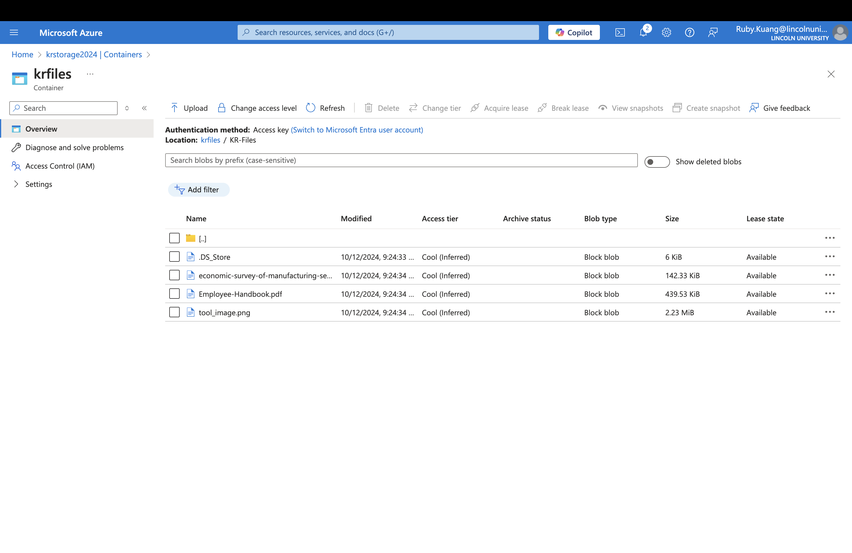
----Data Backup (Backup)----
Tools: Azure Recovery Services Vault
Steps:
- Create a Recovery Services Vault in the Azure portal to store backup data.
- Configure Backup Policies, setting backup frequency and retention periods for virtual machines or databases.
- Outcome:

